CS 509 Team: Capricorn Tianyu Wu

According to User’s Stories and User’s Cases, discuss and sketch Class Diagram with Chen Li. Start with single mode game cause we don’t know how to or what’s the rules to connect to server. The brainstorm results are as follows:

* Game class owns two classes called Player and Board, three attribution (share: Boolean) decide whether the game is able to share and connect with friends or not; (password: Str) create an optional password for the game; (lock: Boolean) if the game is locked by manager or not. Also there’s a game generator constructor need to be decided how to generate a game.
* Player class owns class Info, Cell and Friend, and one attribution called (role: Boolean) decide if this player is game manager or not. Cell can tell which block is belonging to this player by color.
* Info class has (ID: Str) and (IDpassword: Str) two attribution, for database save player’s login info.
* Friend class has an online status for player knowing if his friend is online so can invite.
* Board class owns Cell class, and attribution (size: int) decide the board size NxN.
* Cell class owns Letter class, and three attribution (col: int), (row: int), (color[R,G,B]: int) decide its position and whether the cell is in SHARED BLOCK. Color also tells player where is his playground.
* Letter class has attribution called (char: char) what character it is, (point: int) how many points do this letter worth. Player’s real time score can be calculated by points according to previous score and current score if the word player selected is legal.
* Word class owns Cell class, to decide if the word that player’s picked is legal according to DICTIONARY.

This is just sketch of the class diagram draft, remaining questions are:

* How to connect to server and what would be changed after connected?
* Do we need Friend class to show player’s friends’ online status?
* Word class seems can be optimized, since now it’s self-reliant.

Draw diagram by using Astah together and combine thinking with use cases diagram.

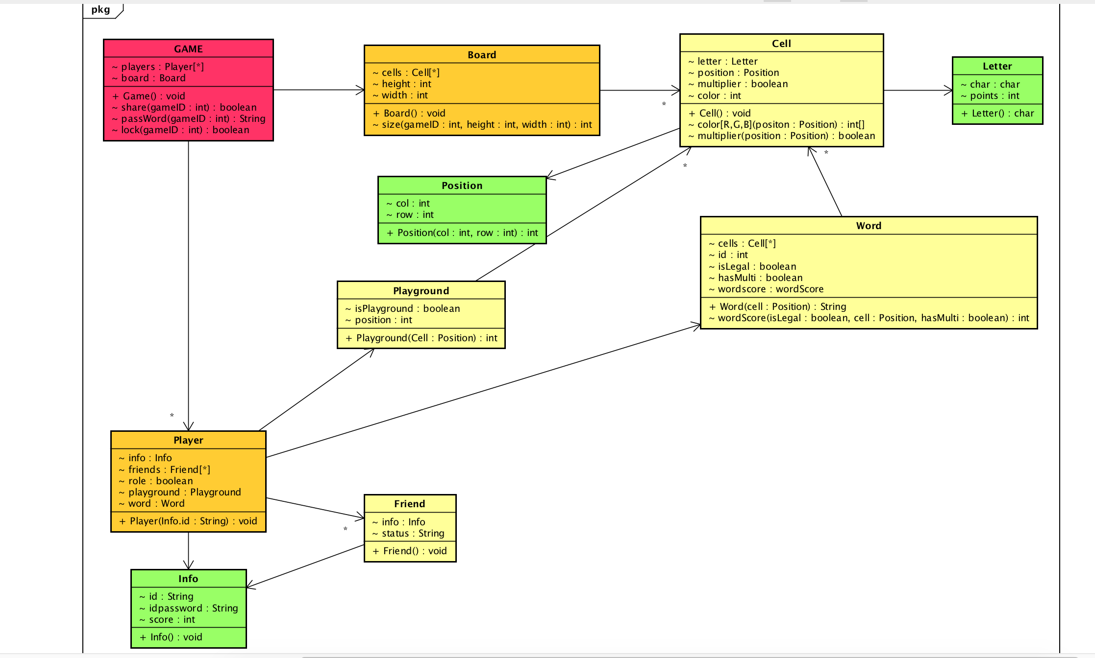 After viewing and thinking according to OO Model provided in MyWPI, second time decision is as following:

* Game class owns two classes called Player and Board, three operations (share: Boolean) decide whether the game is able to share and connect with friends or not; (password: Str) create an optional password for the game; (lock: Boolean) if the game is locked by manager or not. Also there’s a game generator constructor need to be decided how to generate a game.
* Player class owns class Info, Playground and Friend, and one attribution called (role: Boolean) can decide if this player is game manager or not. Cell can tell which block is belonging to this player by color.
* Add a Playground class between player and cell, easier to define which cells would player move and play, which would not.
* Info class has (ID: Str) and (IDpassword: Str) two attribution, for database save player’s login info.
* Friend class has an online status for player knowing if his friend is online so can invite.
* Player also owns Word class, which decide if the word player picked is legal and counting how many points does the player earn with hasMulti attribution or not in this movement.
* Board class owns Cell class, and attribution (size: int) can decide the board size NxN.
* Cell class owns Letter class, Position class and attribution (color[R,G,B]: int) decide its position and whether the cell is in SHARED BLOCK. Color also tells player where is his playground. Multiplier is a Boolean type which decide if the cell is a multiplier.
* Letter class has attribution called (char: char) what character it is, (point: int) how many points do this letter worth.
* Position class is a new class separated from cell, which provide the position for cells.